**Project**

In this project, we are going to take information from a relational database and migrate it to a document-oriented database (MongoDB).

The following tables describe the core data of the relational database.

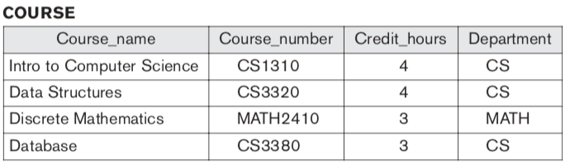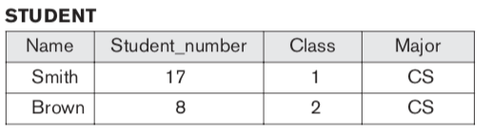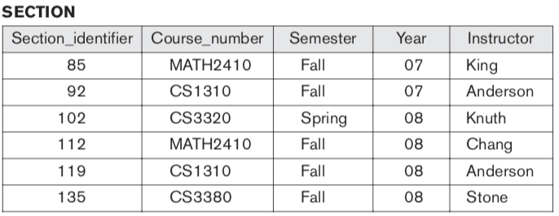

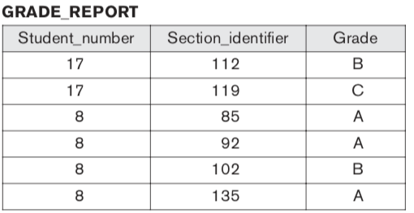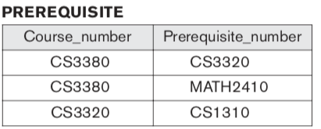

1. [4 Marks] Create a MongoDB with the previous information.
2. [2 Marks] Write a MongoDB query to retrieve the transcript, i.e., a list of courses and grades of “Smith”.
3. [2 Marks] Write a MongoDB query to retrieve the names of the students that took

the section of “Database” course offered in fall 08 and their grades in that section.

1. [2 Marks] Write a MongoDB query to retrieve the course_name of the prerequisites of the “Database” course.